WIDE AREA NETWORK
- Draw a simple diagram (on paper or using an online tool like draw.io) showing how your phone connects to Instagram's servers from your home Wi-Fi, including the ISP and at least two Wide Area Network (WAN) devices (like routers or switches) in the path.

Answer
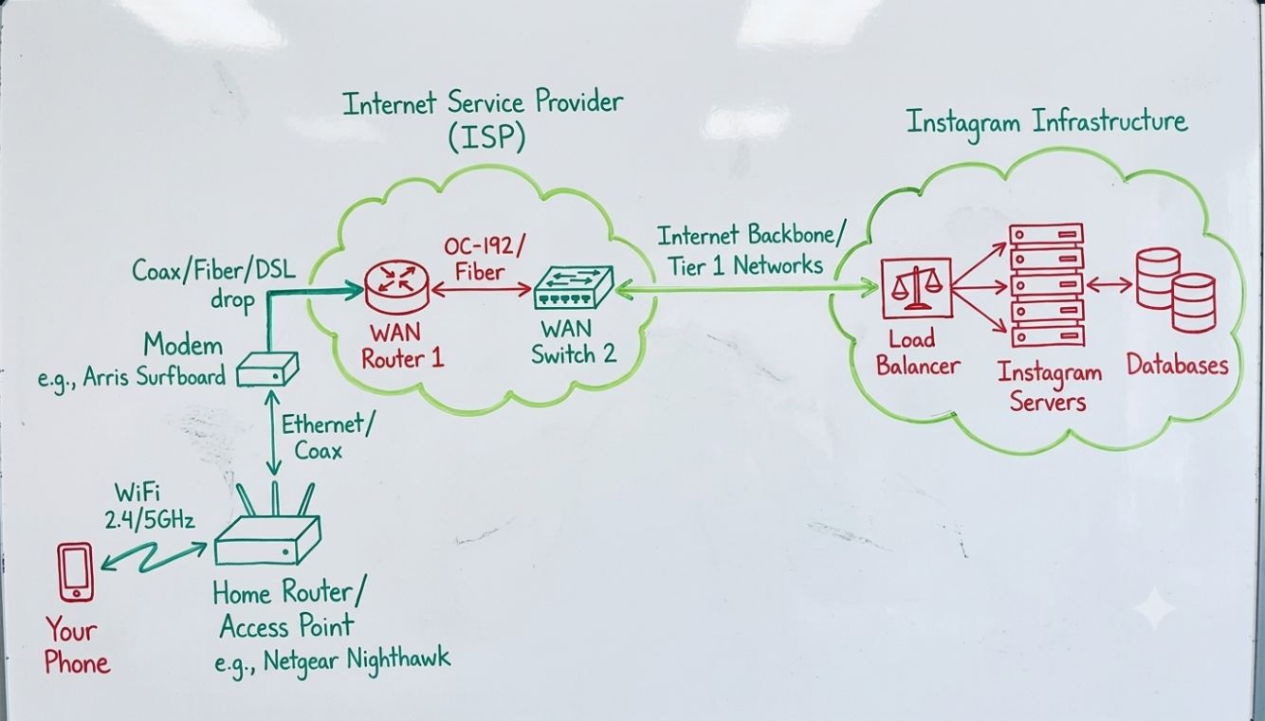
Quick explanation of the path
- Phone → Home Wi-Fi Router – Your phone associates with your home Wi-Fi access point (usually built into the router).
- Home Router → ISP Modem/ONT – Traffic leaves your private network through the modem or optical network terminal that the ISP provided.
- ISP Edge Router – First major WAN device owned by your Internet Service Provider; this is where your traffic enters the ISP’s network.
- ISP Core / Transit Router – Second WAN device (could be another ISP router or a transit provider’s router/switch) that moves the traffic across the wider internet toward Meta’s network.
- Instagram/Meta servers – Traffic finally reaches Meta’s edge servers or CDN nodes, then the actual Instagram application servers.

- Create a table listing three types of WAN technologies (such as MPLS, Leased Line, and Broadband Internet) and compare them based on speed, cost, and where you might see them used in real life (e.g., Zomato office, IRCTC ticketing, your home).
Answer
WAN Technologies Comparison Table
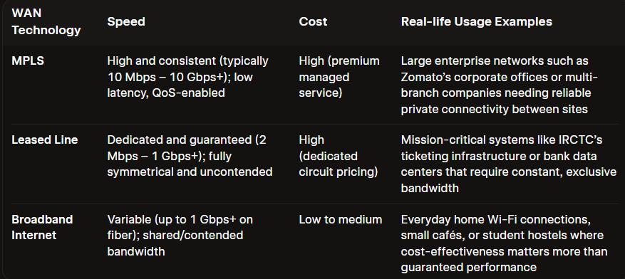
- Research and write a short explanation of how a VPN (Virtual Private Network) uses WANs to let you access apps like Spotify or YouTube securely from a public Wi-Fi at a coffee shop. Focus on how the VPN creates a private tunnel over the public WAN.
Answer

A VPN (Virtual Private Network) lets you use apps like Spotify or YouTube securely on public Wi-Fi by creating a private, encrypted “tunnel” over the public WAN (the internet).
When you connect to a VPN at a coffee shop:
- Your phone/laptop first joins the café’s Wi-Fi and gets a local IP address.
- The VPN client on your device then sets up an encrypted connection (tunnel) to a VPN server over the public internet (the WAN).
- All your traffic to Spotify, YouTube, and other apps is wrapped inside this encrypted tunnel, so anyone on the same Wi-Fi (or the café’s router) can see only that you’re sending data to the VPN server, not what you’re watching or listening to.
- From the VPN server onward, your traffic goes out to Spotify/YouTube as if it were coming from the VPN server’s location, not the coffee shop.
So, the WAN (internet) is still the underlying network, but the VPN makes your part of it private and secure by encrypting everything between your device and the VPN server

- Imagine Flipkart wants to connect its warehouses in Ahmedabad, Mumbai, and Delhi. Suggest which WAN technology would be best for them and justify your answer with two reasons.
Answer
Why MPLS is suitable:
- Secure, reliable connectivity between multiple sites
  - MPLS creates a private, logically separated network over the service provider’s WAN.
  - Traffic between Ahmedabad, Mumbai, and Delhi stays within Flipkart’s MPLS cloud, reducing exposure to the public internet and helping protect inventory, order, and customer data.
- Good performance and traffic prioritization for critical apps
  - MPLS supports Quality of Service (QoS), so Flipkart can prioritize important traffic (e.g., warehouse management systems, real-time inventory updates) over less critical traffic.
  - This gives more predictable latency and fewer disruptions than plain broadband internet, which is important for smooth operations across multiple cities.

